St Michael’s Pre-School Ethos
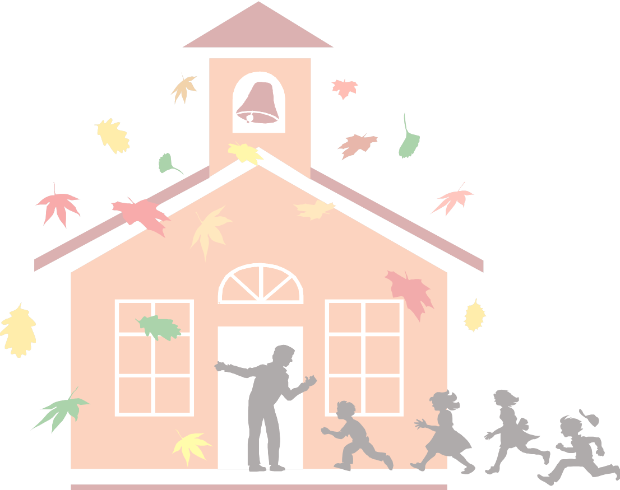
At St Michael’s Pre-school we provide a warm, caring, enabling environment where children are safe and stimulated to explore and make sense of their world and their learning, enabling them to build on their existing knowledge. We recognise that young children’s learning is holistic and provide a flexible, stimulating, challenging, yet achievable, inclusive curriculum based on our children’s individual interests, learning styles, abilities, age-stage, cultures, and backgrounds. Our provision includes loose parts and resources which stimulates children’s curiosity, awe and wonder whilst developing their imagination, social and communication skills. Skilful practitioners recognise teachable moments in which to build upon children’s knowledge and understanding. Each child is observed, enabling practitioners to gain a deeper understanding of children’s perspectives of their environment. All children are valued and respected for their own abilities, interests, ideas, thoughts, and opinions – every child is unique. We actively promote inclusion, diversity, decision making, free choice and encourage children to take risks. We acknowledge the importance of The Child’s Voice; promoting communication skills in all areas of our setting. Our children will develop into competent, resilient learners who are intrinsically driven to explore and discover whilst recognising and embracing their own and other’s abilities and limitations.

We recognise that families are the first and most powerful influence on childhood learning and development. Practitioners, creating positive relationships with families provides children with the best learning and development opportunities. We acknowledge that care and learning are inseparable. We acknowledge, respect, and welcome all families regardless of their socio-economic, cultural and linguistic backgrounds, acknowledging that these factors create their own unique experiences, which we want to share and build upon. We provide opportunities for all children to be part of the community, helping them to take part in society and develop their own cultural and spiritual beliefs. We recognise the web of family and community are the children’s key anchor for early development.

We recognise the importance of providing our children with the opportunity to explore all areas of the environment and provide free-flow indoor/outdoor play, which develops healthy bodies and minds. We actively promote all aspects of healthy living and positive life-style choices.

“If children feel safe, they can take risks, ask questions, make mistakes, learn to trust, share their feelings, and grow.” ~ Alfie Kohn

“Every day, in a 100 small ways, our children ask, ‘Do you hear me? Do you see me? Do I matter?’ Their behavior often reflects our response.” ~ L.R. Knost

“Teaching is not about answering questions but about raising questions – opening doors for them in places that they could not imagine.” ~ Yawar Baig

