
St Michaels preschool
Charity number:- 1110379
A committee guide for a committee run setting
We need parents/carers support to stay open.

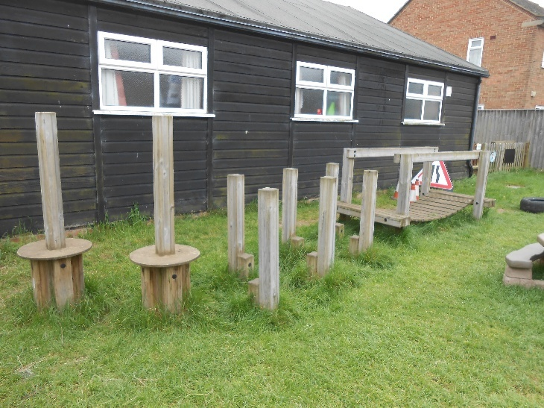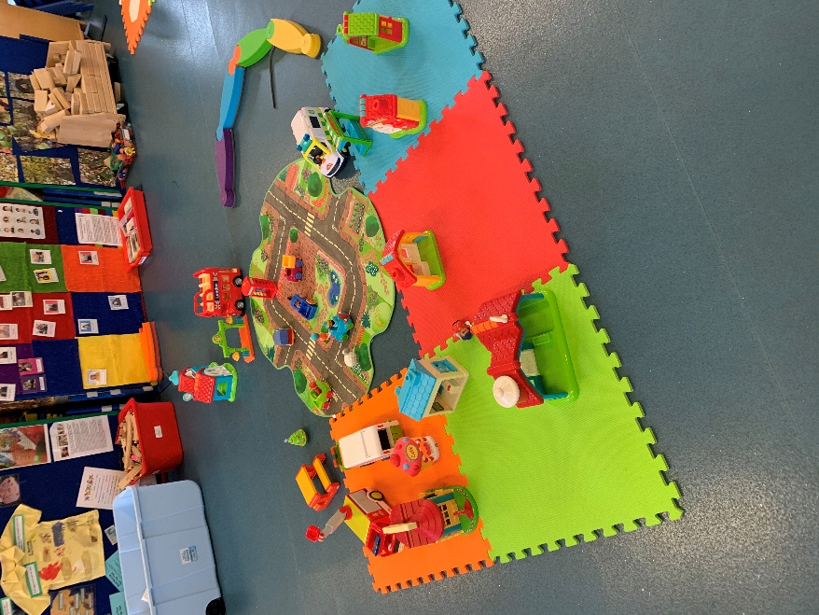
Committee membership is enjoyable and rewarding, allowing individuals to contribute their skills and ideas while gaining new abilities in management, marketing, and recruitment.

Support from parents and carers is essential for keeping our preschool running. Your involvement makes it possible for us to continue making a positive impact on children's futures and nurturing their growth. Without you we will close.
What to expert at the AGM
The AGM will elect new committee members and vote on adopting the latest constitution. Existing officers may be re-elected if agreed prior; the date for the first committee meeting should be set at the AGM and held within two weeks.
Three officer positions need to be filled: chairperson, secretary, and treasurer. Members should be nominated for these roles, and each nomination must be seconded and formally agreed upon by the group. If more than one person is nominated for a position, the committee should hold a vote. Minutes of this process must be recorded.
New committee members.
Here are a few details about how we run and what we do.
Constitution
Our constitution can be found on our website and in the main room of preschool on the notice board inside.
It is our governing document. Please do read it. It is legal document that explains how the committee must operate. The setting is registered with the charity commissions.
Meetings
We hold a minimum of 4 meetings a year where the majority of committee members have to join to make sure we are abiding by the constitution.
We host an annual general meeting every December and invite all parents to attend.
Roles and Responsibilities
The committee
- Are collectively responsible for managing the setting
- Must appoint a Chairperson, treasurer and a secretary plus general committee members
- Must be aware of and comply with current legislation
- Recruit safer robust, safe recruitment procedures according to the current Statutory Framework 2025.
- Chairperson managers the manager who managers the staff
- Must do their best to ensure the financial stability of the setting
- Must try to recruit future members of the committee
- Can have a fundraising sub-group
Finances
As a charity or non-profit organisation, all of our finances are allocated for the benefit of the children who attend our setting. In accordance with charity law, we maintain a contingency fund. We organise a range of fundraising events each year and welcome new suggestions for activities. Volunteers may claim reimbursement for relevant and legitimate expenses.

Committee Responsibilities
A committee (members can be referred to as Trustees) is a group of people who ensure that an organisation fulfils all its legal obligations and operates efficiently and according to their constitution and Ofsted requirements. As a governing body they will need to have a shared vision of what the organisation is about and what its end goals might be. The committee is responsible for the overall management and organisation of the setting.
We are part of the Pre-School Learning Alliance model constitution 2011, so the committee can have a minimum of 5 and a maximum of 12 members (including officers). 60% of committee members should be parents unless special arrangements are made through the Alliance National Centre.
Committee members are encouraged to collaborate with the Day to Day Supervisor to build a strong working relationship, ensuring that legal obligations and childcare arrangements have clear, appropriate goals.
The committee ensures that strong business and employment practices are established and maintained, while also meeting all legal requirements. They are responsible for making sure that any decisions support the long-term sustainability and success of the organization.
The committee ensures supervisions occur every eight weeks and appraisals annually. Supervision should promote mutual support, teamwork, ongoing improvement, and allow confidential discussion of sensitive matters.
Committee members should actively participate in training and development to keep governance compliant and effective.
The committee is required by Ofsted to appoint a ‘nominated individual’ who will act on behalf of the organisation in its dealings with Ofsted. This person can be the day to day supervisor, but they must be a member of the governing body (committee). (This is the Manager).
This is not a daunting as it sounds the staff at the preschool are here to help and offer guidance if needed.

Committee Roles
Chairperson
Job Description
- The public face of the committee, the Chairperson is expected to represent the group in an official capacity when needed.
• Chair and Manager ensure that meetings run effectively.
• Present a report at the AGM helped by the Manager
• Helps with recruitment of staff
• Supports the Treasurer and Secretary as needed
• Helps make decisions in the event of a crisis.
- Partakes in the Manager appraisal
Treasurer
Job descriptions
• Is responsible for reporting to the committee all matters to do with the group’s finances.
- Laisse with the accountant when needed
• Approves expenses, as one of two signatories.
. • Presents a financial report supplied by the accountant at each committee meeting.
• Works with the accountant to ensure there is an annual independent examination of accounts and they are submitted to the Charity Commission each June. (accountant does this)
• Presents an annual financial report at the AGM.
Secretary
Job Description
• Attends committee meetings and any other meetings where it is required to take minutes send to Manager to share.

We hope to see you at the AGM
Thank you for your support. We do hope you will become a committee volunteer.

